**Palo alto CORTEX XDR**

**What is XDR?**

* XDR stands for Extended Detection and Response
* It is an integrated security platform designed to provide comprehensive threat detection and incident response capabilities across an organization's digital environment

**Cortex XDR:**

Cortex XDR is the industries 1st Extended Detection and Response platform, that spanning all data sources to stop Moden attacks using Next-level endpoint protection and AI-Driven Threat Detection

The Cortex XDR app provides complete visibility into all your data in the Data Layer. The app provides a single interface from which you can investigate and triage alerts, take remediation actions, and define policies to detect malicious activity in the future.

* **Data Integration:** Cortex XDR aggregates and correlates data from multiple sources, including endpoints, network traffic, cloud services, email, and more. This comprehensive data integration provides a holistic view of the organization's security landscape.
* **Advanced Threat Detection:** Cortex XDR employs machine learning and behavioural analytics to detect advanced and evasive threats. It can identify suspicious activities and anomalies across the network and endpoints.
* **Behavioural Analytics:** The platform uses user and entity behaviour analytics (UEBA) to track and analyse the behaviour of users and devices. This helps in identifying unusual or potentially malicious activities.
* **Automated Threat Hunting**: Cortex XDR includes automated threat hunting capabilities that proactively search for signs of compromise and potential threats. This reduces the reliance on manual analysis and accelerates detection.
* **Incident Investigation:** Cortex XDR provides tools for security analysts to investigate security incidents. It offers detailed timelines, context, and root cause analysis to streamline the investigation process.
* **Automated Response:** The platform includes automated response capabilities to contain and mitigate threats quickly. Security teams can define playbooks for automated responses to known threats.
* **Customizable Dashboards**: Cortex XDR offers customizable dashboards and reporting to provide real-time insights into the security posture of the organization. This helps security teams make data-driven decisions.
* **Threat Intelligence Integration:** The platform integrates with external threat intelligence feeds to stay updated on the latest threats and indicators of compromise (IoCs).
* **Compliance and Reporting**: Cortex XDR includes compliance and reporting features to assist with regulatory compliance and auditing requirements.
* **Multi-Cloud Support**: It can provide visibility and security for workloads across multi-cloud environments, ensuring consistent protection.
* **Integration with Palo Alto Networks Security Ecosystem:** Cortex XDR seamlessly integrates with other Palo Alto Networks security products, such as the Palo Alto Networks Next-Generation Firewall and Prisma Cloud, to create a unified security ecosystem.
* **Continuous Monitoring:** The platform offers continuous monitoring and retrospective analysis, allowing organizations to review historical data to identify past incidents or trends.

**Architecture of Cortex XDR:**

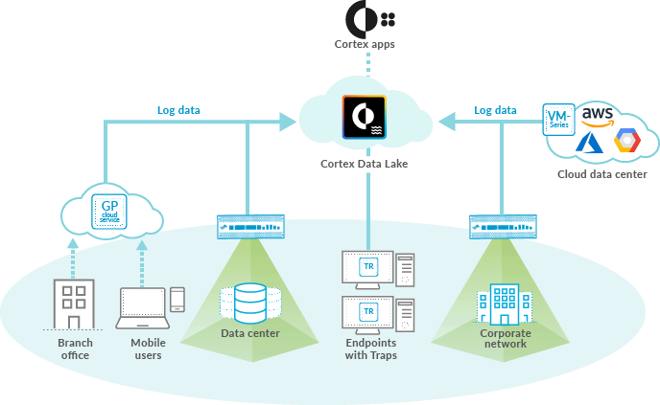

**Data Lake:**

* Radically simplify your security operations by collecting, integrating, and normalizing your enterprise’s security data.
* Effortlessly run advanced AI and machine learning with cloud-scale data and compute.

**License purchase: Deployment Scoping**

<https://apps.paloaltonetworks.com/cortex-sizing-estimator>

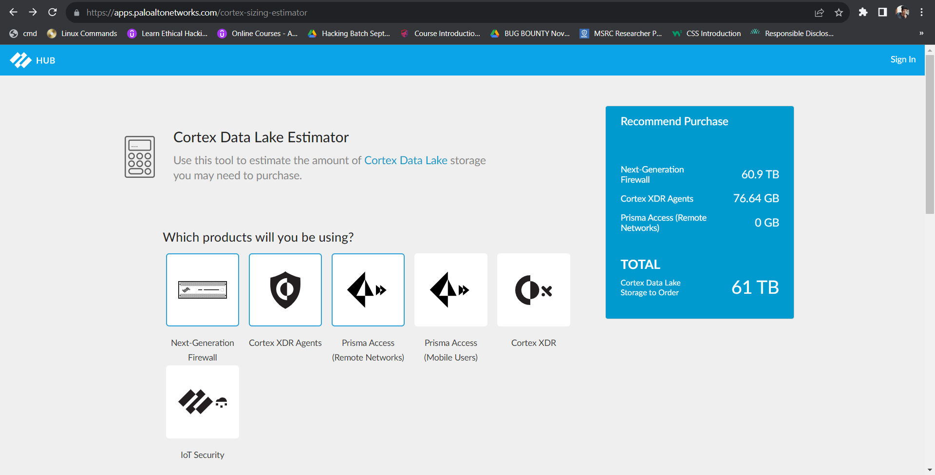

**Landing Page:**

<https://cortex-gateway.paloaltonetworks.com/signin/>

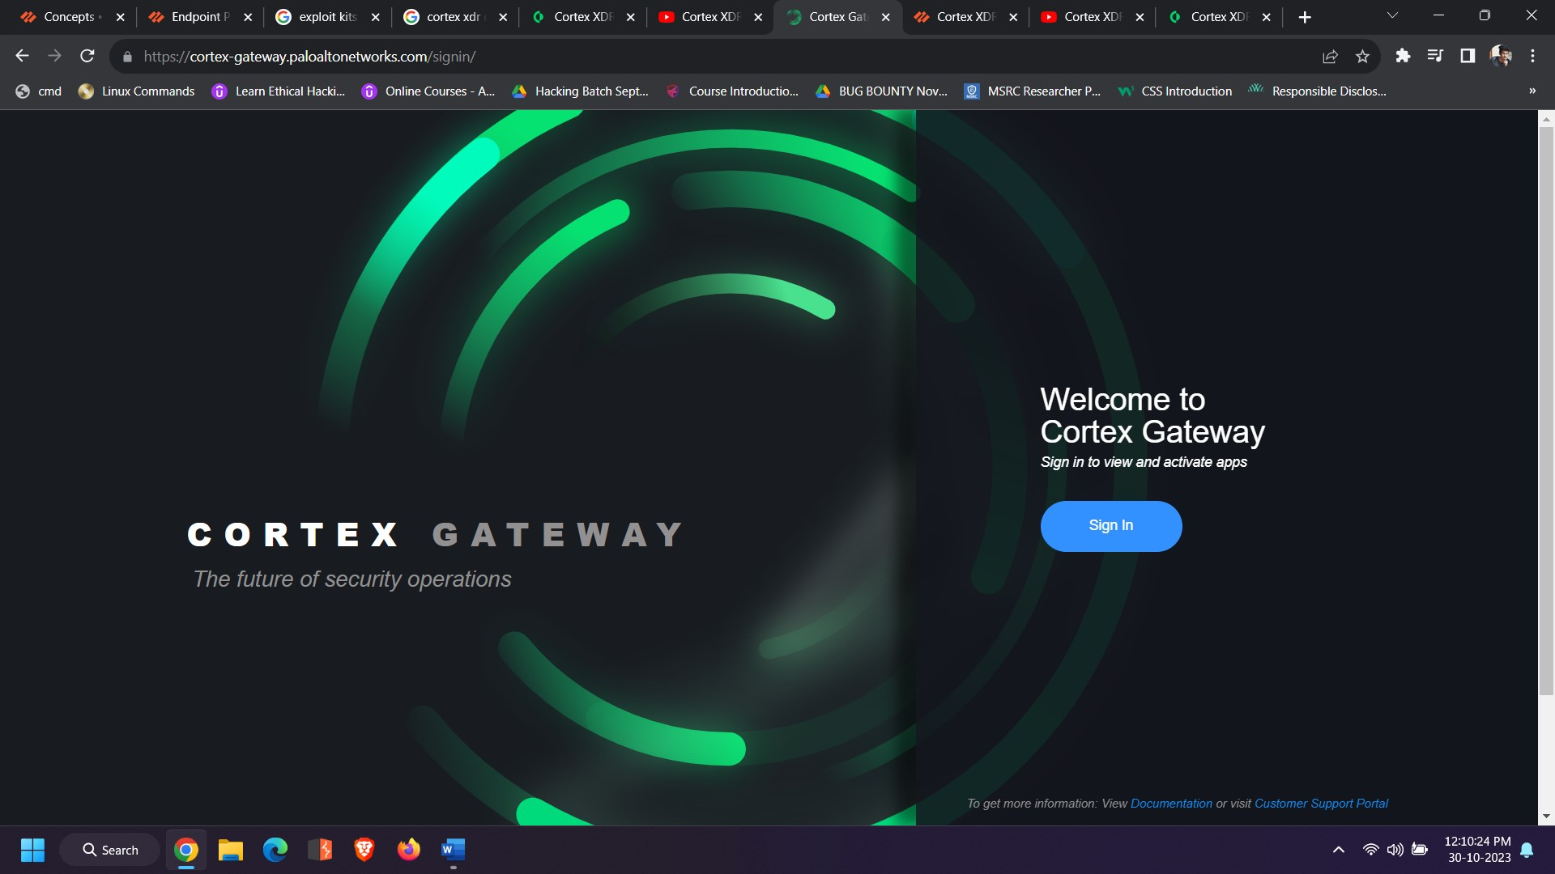

**Register in Customer Support Portal:**

**Sign in Using CSP (Customer Support Portal) credential:**

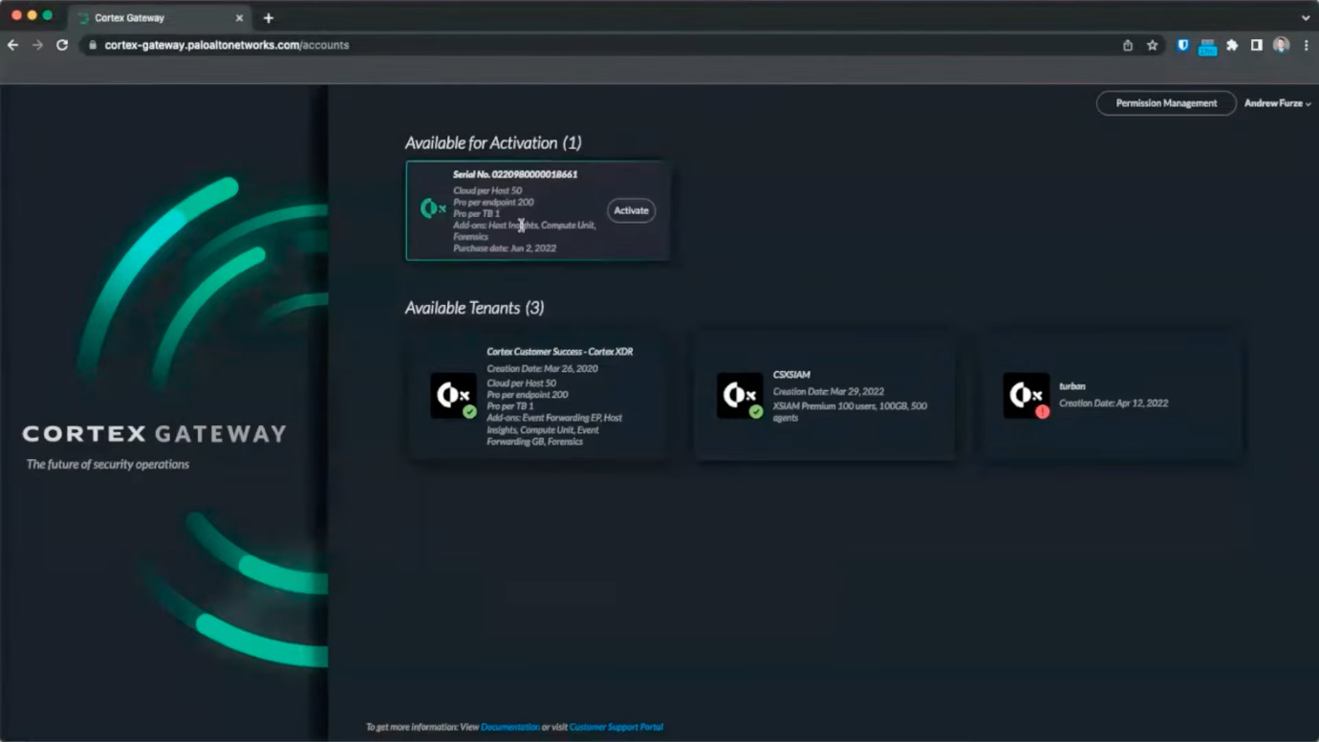

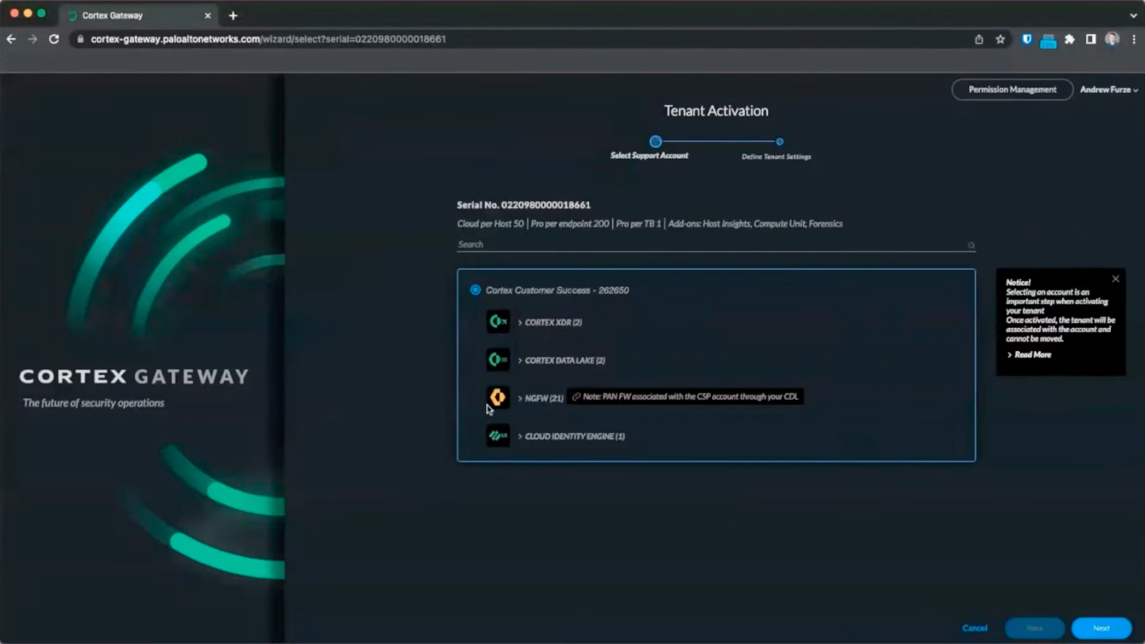

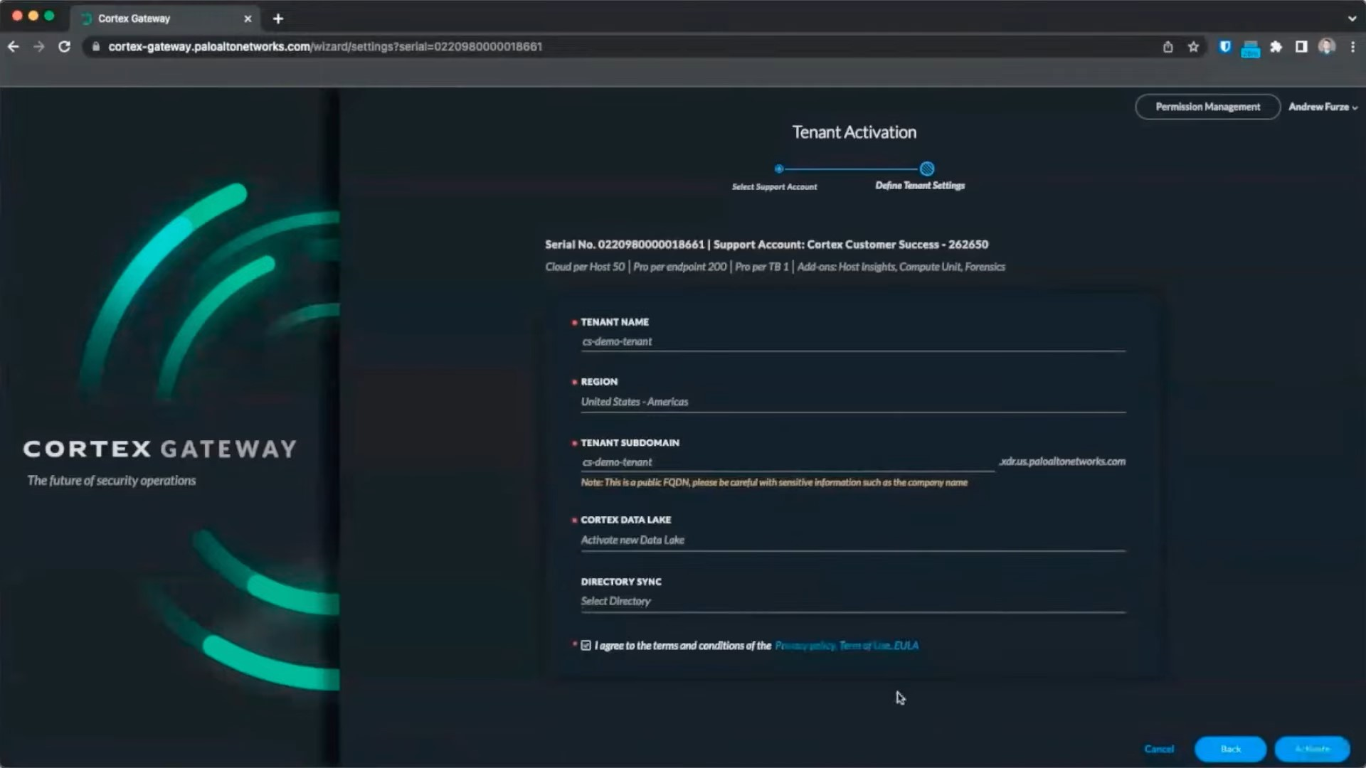

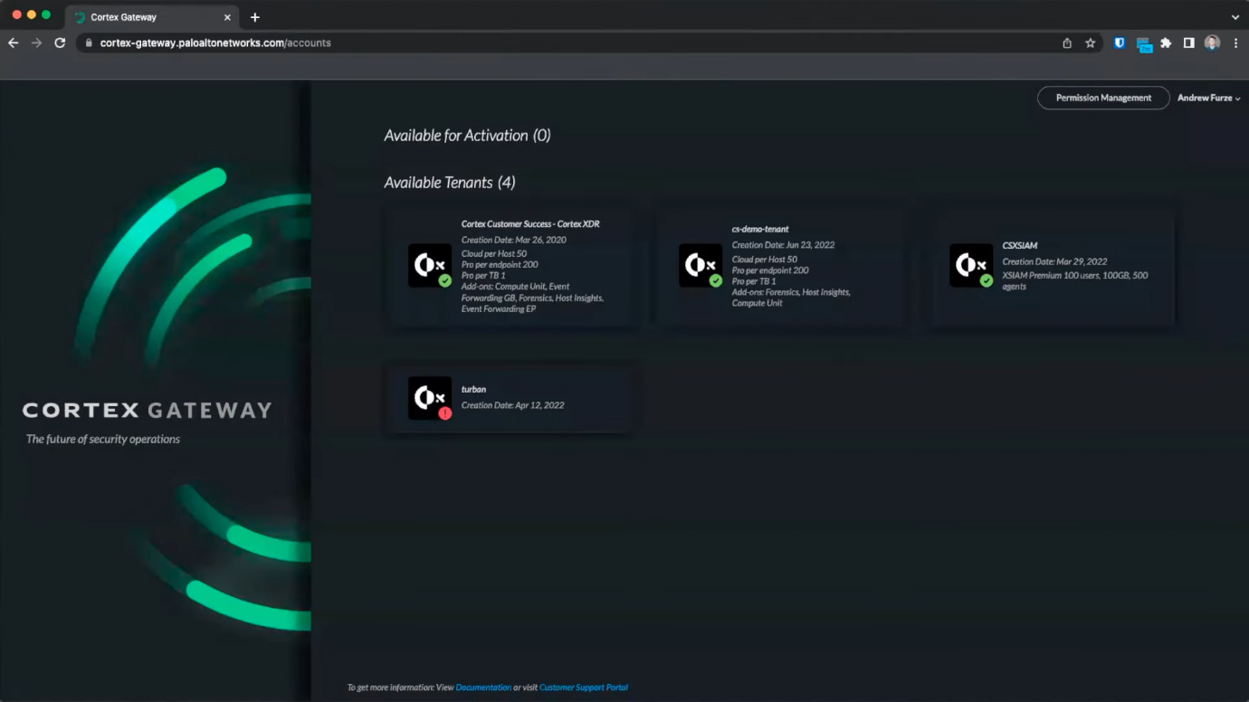

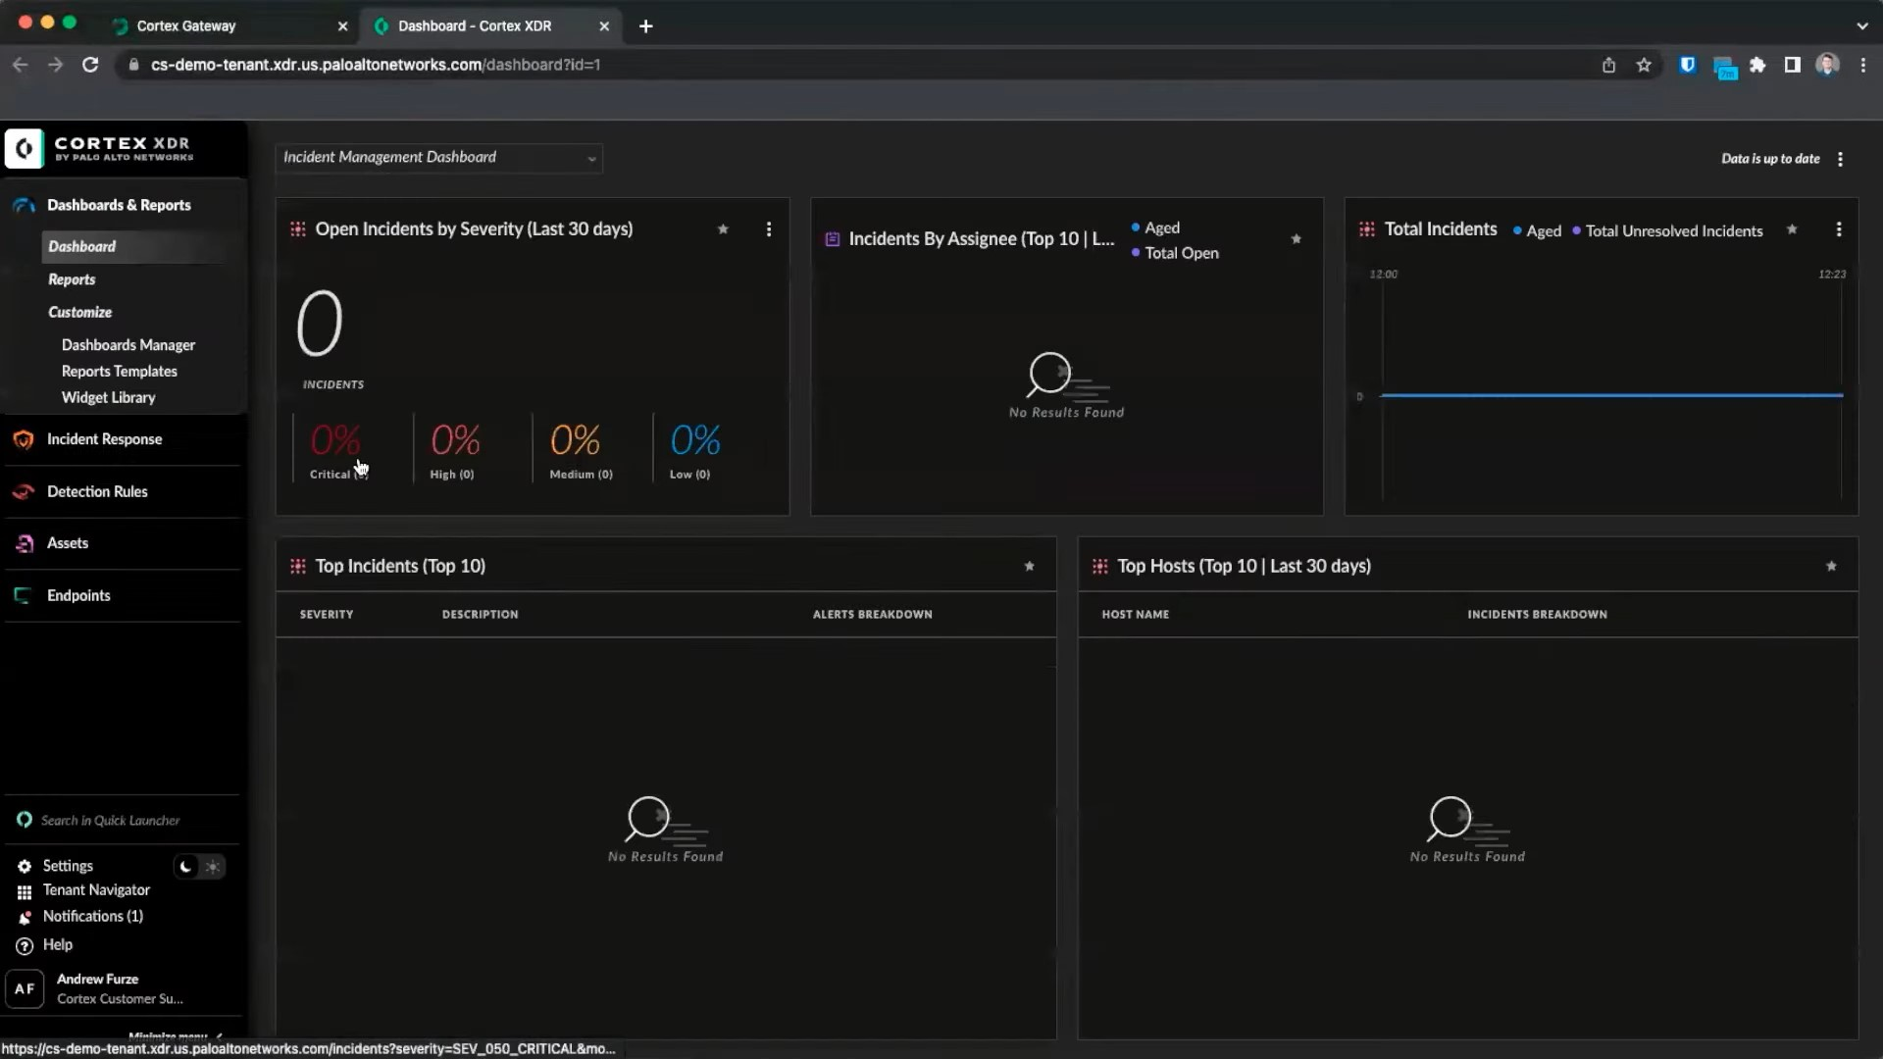

1. **Dashboards & Reports**
2. **Incident Response**
3. **Detection Rules**
4. **Assets**
5. **Endpoint**

**1.Dashboards & Reports:**

1. **Dashboards**
2. **Reports**
3. **Customize**

* **Dashboards Manager**
* **Reports Templates**
* **Widget library**

**Dashboards**

The dashboard comprises dashboard widgets that summarize information about your endpoint in graphical or tabular format. From the dashboard header, a drop-down menu lists all Predefined and Custom dashboards. On the right of the header, you can select the Time Range for the dashboard. You can also select widget specific timeframes from the menu on a widget. If you select a different timeframe for a widget, a clock icon is displayed.

**Reports**

Reports contain statistical data in the form of widgets, which enable you to analyse data from inside or outside Cortex XDR, in different formats such as graphs, pie charts, or text from information. After generating a report, it also appears in the Reports tab, so you can use the report again.

* **Build a Custom Dashboard**

In the Cortex XDR console, navigate to **Dashboards & Reports → Customize → Dashboards Manager** to view all custom and default dashboards. From the Dashboards Manager, you can also delete, edit, duplicate, disable, and perform additional management actions on your dashboards.

To manage an existing dashboard, right-click the dashboard and select the desired action.

* **Delete** - Permanently delete a dashboard.
* **Edit** - Edit an existing dashboard. You cannot edit the default dashboards provided by Palo Alto Networks, but you can save it as a new dashboard.
* **Save as new -** Duplicate an existing template.
* **Disable** - Temporarily disable a dashboard. If the dashboard is public, this dashboard is also removed for all users.
* **Set as default -** Make the dashboard the default dashboard that displays when you (and other users, if the dashboard is public) log in to Cortex XDR .
* **Save as report template -** Save a report as a template.
* **Report Templates -** On the Report Templates page, you can view, delete, import, create, and modify report templates. You can also select and generate multiple reports.
* **Manage Your Widget Library -** The widget library displays predefined widgets and user-created custom widgets. You can include these widgets in your custom dashboards and reports. To access the widget library, navigate to **Dashboards & Reports → Customize → Widget Library.**

**2.Incident Response:**

**Incident:**

An attack can affect several hosts or users and raises different alert types stemming from a single event. All artifacts, assets, and alerts from a threat event are gathered into an **Incident**.

Incident include Score, severity and key assets.

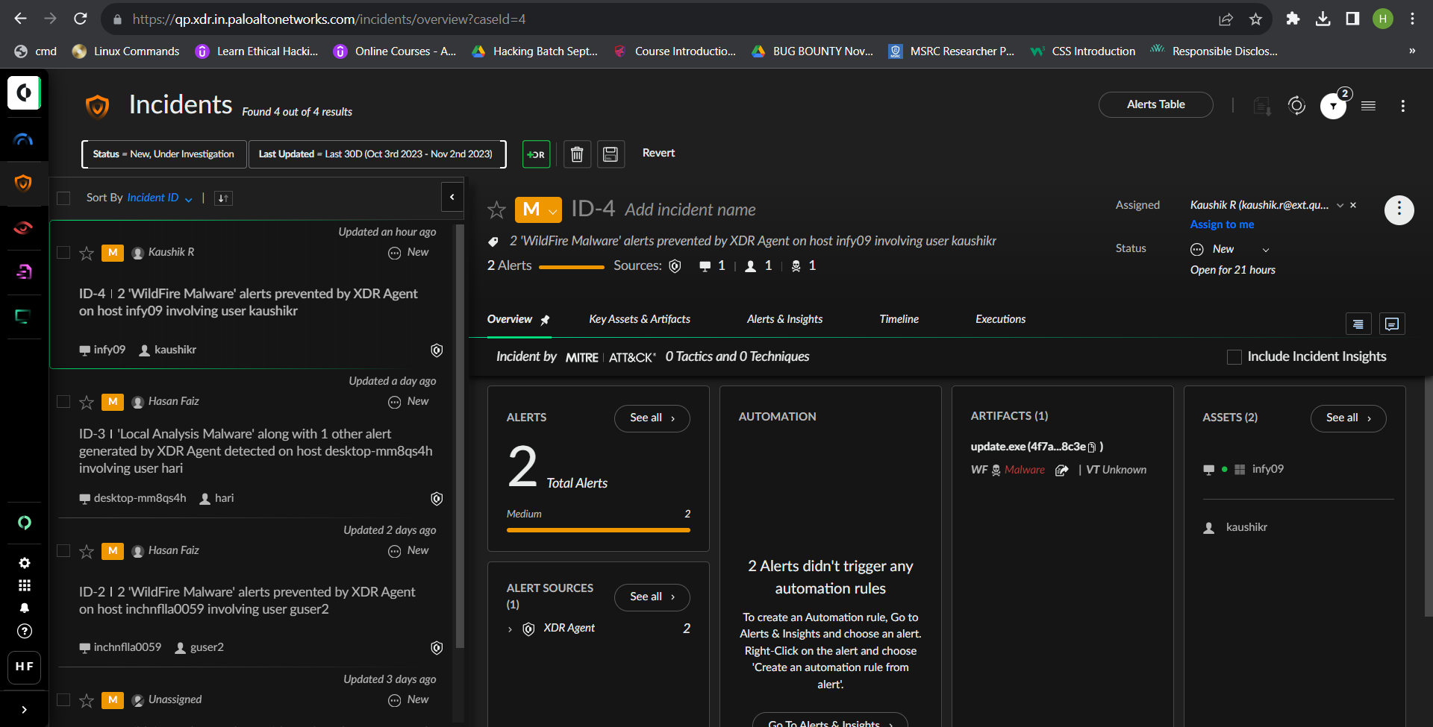

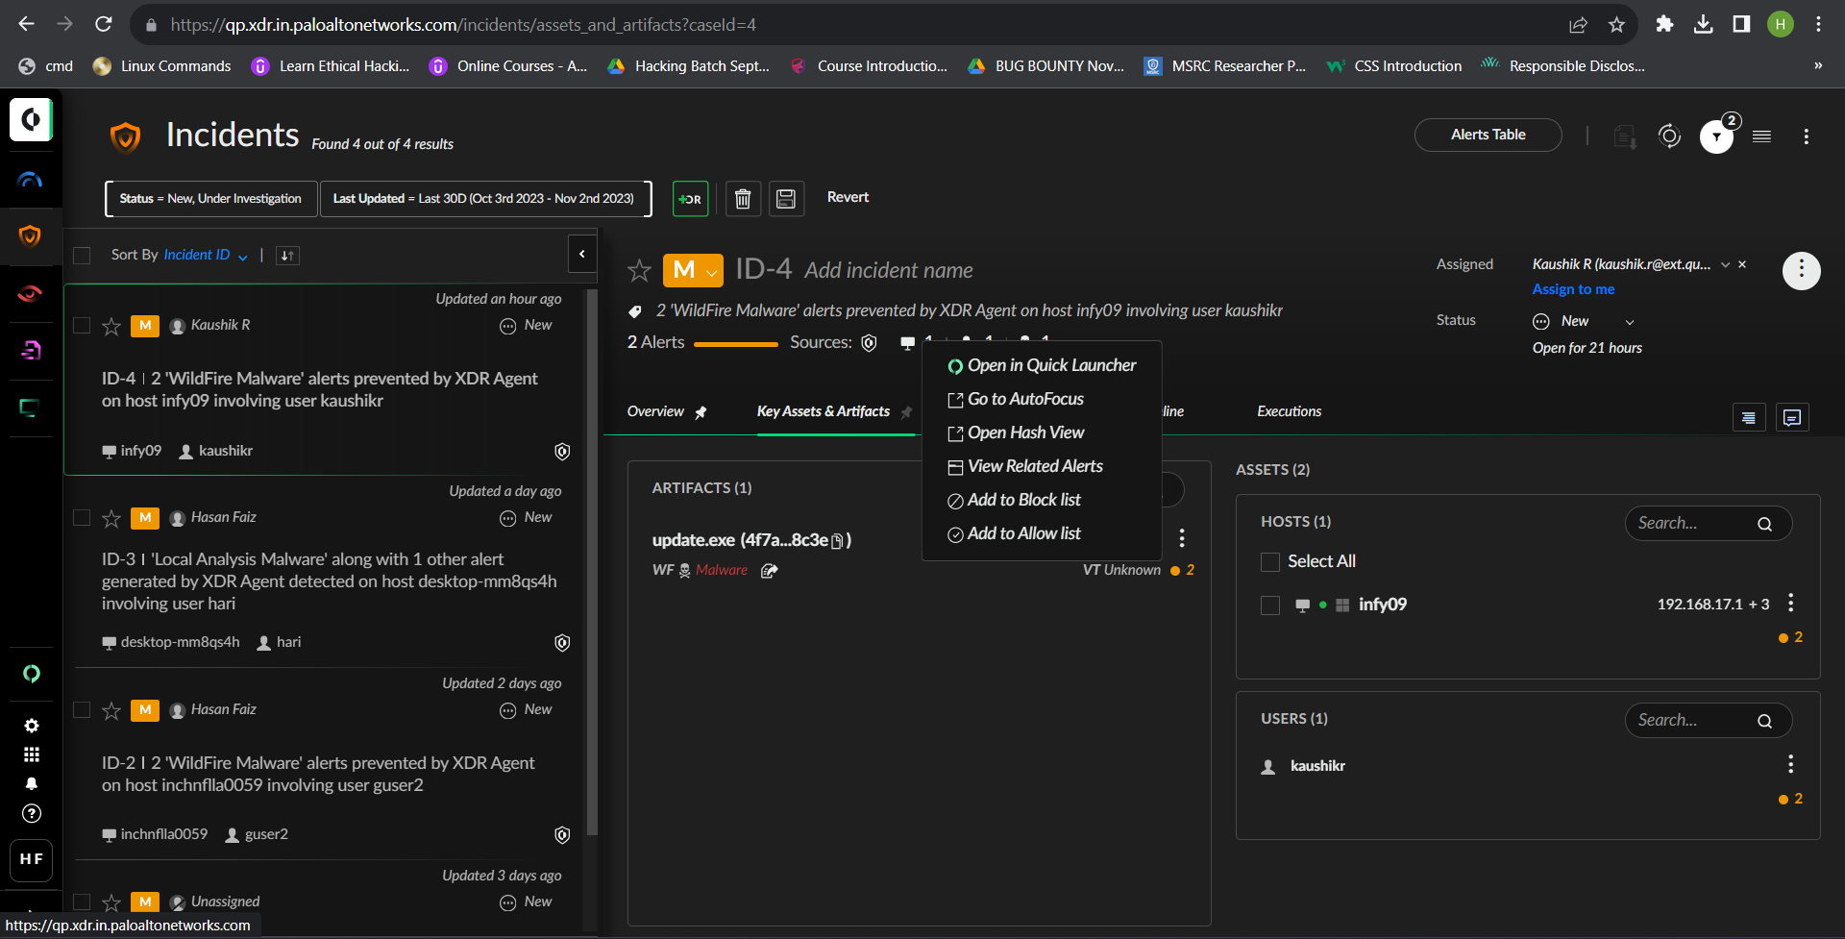

**Investigation:**

**Query Builder:**

The Query Builder provides queries for the following types of entities:

* **Process—**Search on process execution and injection by process name, hash, path, command line arguments, and more.
* **File—**Search on file creation and modification activity by file name and path.
* **Network—**Search network activity by IP address, port, host name, protocol, and more.
* **Registry—**Search on registry creation and modification activity by key, key value, path, and data.
* **Event Log—**Search Windows event logs and Linux system authentication logs by username, log event ID (Windows only), log level, and message.
* **Network Connections—**Search security event logs by firewall logs, endpoint raw data over your network.
* **All Actions—**Search across all network, registry, file, and process activity by endpoint or process.

**Query Center**

From the Query Center you can manage and view the results of all simple and complex queries created from the **Query Builder**.

**Manage Quarantined Files**

When the agent detects malware on a Windows endpoint, you can take additional precautions to quarantine the file.

To evaluate whether an executable file is considered malicious, the agent calculates a verdict using information from the following sources in order of priority:

* Hash exception policy
* Wildfire threat intelligence
* Local analysis

Quarantining a file in Cortex XDR can be done in one of two ways:

* Enable the agent to automatically quarantine malicious executables by configuring quarantine settings in the Malware security profile.
* Right-click a specific file from the causality card and select Quarantine.

**Scheduled Queries:**

From the Scheduled Queries page, can easily view all scheduled and reoccurring queries created from the Query Builder.

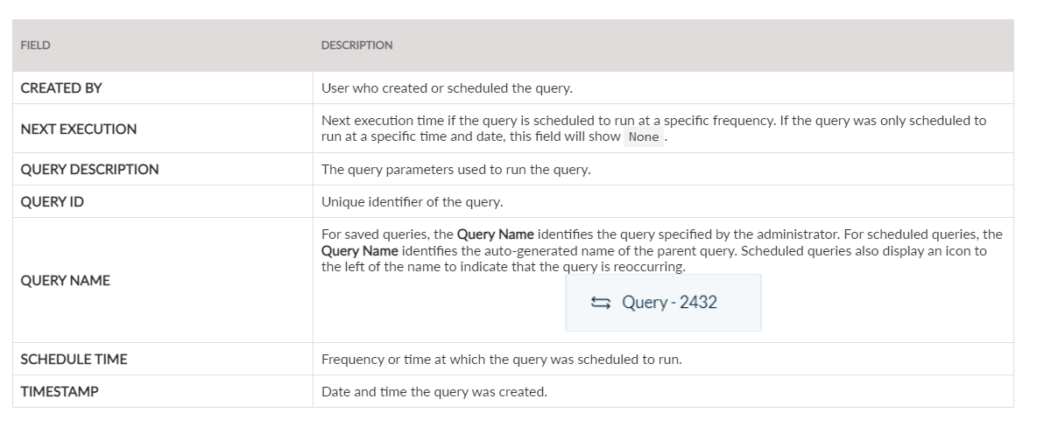

**Forensics:**

The Cortex XDR Forensics end-to-end solution streamlines your incident response, data collection, threat hunting, and analyses of your endpoint. By activating the Forensics add-on, Cortex XDR enables you to find the source and scope of an attack, and to determine what, if any, data was accessed.

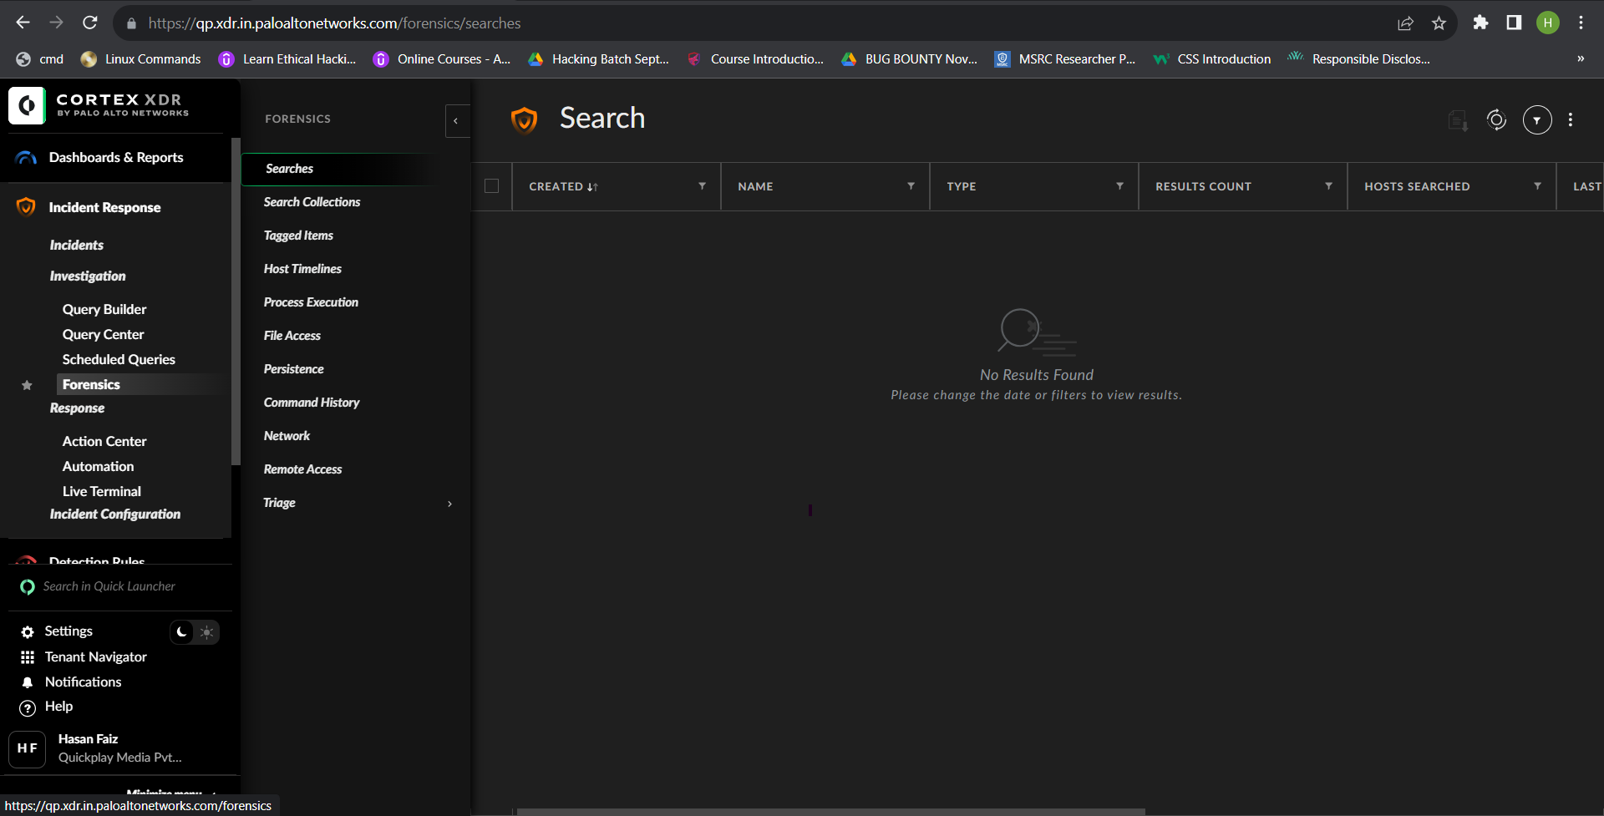

1. **Searches -** Displays details of forensic searches run by users or as part of a Search Collection.
2. **Search Collections -** Displays the collections of forensic searches saved under a collection name.
3. **Tagged Items -** Displays the list of forensic artifacts that were tagged.

* Tags offer you a way to label a particular row of data using a word or phrase that identifies its relevance to your investigation.

1. **Host Timelines -** Displays a list of normalized, per-host timelines that include multiple forensic artifacts in a single table.
2. **Process Execution -** Displays details of process executions.
3. **Process Execution Artifacts -** Displays details of the following type of process execution artifacts:

**Windows**

* Amcache—A registry hive used by the Application Compatibility Infrastructure to cache the details of executed or installed programs.
* Application Resource Usage —A table in the System Resource Usage database that stores statistics pertaining to resource usage by running applications.
* Background Activity Monitor—Per-user registry keys created by Background Activity Monitor (BAM) service to store the full paths of executable files and a timestamp, indicating when they were last executed.
* CidSizeMRU—A registry key containing a list of recently launched applications.
* LastVisitedPidMRU—A registry key containing a list of the applications and folder paths associated with recently opened files found in the user’s OpenSavePidMRU key.
* Prefetch—A type of file created to optimize application startup in Windows. These files contains a run count for each application, between one and eight timestamps of the most recent executions, and a record of all of the files opened for a set duration after the application was started.
* Recentfilecache—A cache created by the Application Compatibility Infrastructure to store the details of executed or installed programs (Windows 7 only).
* Shimcache—A registry key used by the Application Compatibility Infrastructure to cache details about local executables.
* UserAssist—A registry value that records a count for each application that a user launches via the Windows UI.
* Windows Activities—A database containing user activity for a particular Microsoft user account, potentially across multiple devices. This is also called the Windows Timeline.

**macOS**

* CoreAnalytics—A diagnostic log that contains details of files executed on the system.
* Recent Applications—A plist file located within a user's Library directory that contains a list of applications opened by that user.
* **File Access -** Displays details of file access artifacts.
* **File Access Artifacts -** Displays details of the following type of file access artifacts:

**Windows**

* 7-Zip Folder History—A registry key containing a list of archive files accessed using 7-Zip.
* Recent Files—Contents of the shortcut (.lnk) files found in a user's Recent folder. These files represent files recently accessed for a user account.
* Jumplist—A feature of the Windows Task bar that provides shortcuts to users for recently accessed files or applications.
* OpenSavePidiMRU—A registry key containing a list of recently opened and saved files for a user’s account.
* Recycle Bin—Folder used by Windows as temporary storage for deleted files prior to permanent deletion.
* ShellBags—Registry keys that record user layout preferences for each folder with which the user interacts.
* TypedPaths—A registry key containing a list of paths that the user typed into the Windows Explorer path bar.
* WinRARArcHistory—A registry key containing a list of archive files accessed using WinRAR.
* WordWheelQuery—Registry key containing a list of terms that a user searched for in Windows Explorer.

**macOS**

* Recent Documents—Plist files located within a user's Library directory that contain a list of documents accessed by that user.
* Spotlight Shortcuts—A plist file that contains the Spotlight search terms entered by each user and the items that they selected from the search results
* **Persistence -** Displays details of the persistence artifacts.
* **Persistence Artifacts -** Displays details of the following type of persistence artifacts:

**Windows**

* Drivers—Windows device drivers installed on each endpoint.
* Registry—A collection of registry keys that can be used for malware persistence.
* Scheduled Tasks—Tasks used to execute Windows programs or scripts at specified intervals.
* Services—Windows applications that run in the background and do not require user interaction.
* Shim Databases—Databases used by the Application Compatibility Infrastructure to apply shims to executables for backwards compatibility. These databases can be used to inject malicious code into legitimate processes and maintain persistence on an endpoint.
* Startup Folder—Contents of the shortcut .lnk files found in the StartUp folder for both the system and users. The folders are used to automatically launch applications during system startup or user logon processes.
* WMI—List of WMI EventConsumers and any EventFilters that are bound to them using a FilterToConsumerBinding. WMI EventConsumers can be used as a method of fileless malware persistence.

**macOS**

* Cron—A system utility that executes programs or scripts at specified intervals.
* Launchd—Listing of applications and daemons configured to launch using the launchd process.
* LoginItems—Plist files containing applications, files, or folders configured to launch during user login.
* **Command History -** Displays details of the command history.
* **Command History Artifacts -** Displays details of the following type of command history artifacts:

**Windows**

* PSReadline—A record of commands typed into a PowerShell terminal by user. The history file is only enabled by default, starting with Powershell 5 on Windows 10 or newer.

**macOS**

* Shell History—Commands recorded to the history files for Bash and Zsh shells.
* **Network -** Displays details of the network activity.
* **Network Artifacts -** Displays details of the following type of network artifacts:

**Windows**

* ARP Cache—A cache of Address Resolution Protocol (ARP) records for resolved MAC and IP addresses.
* DNS Cache—A cache of Domain Name System (DNS) records for resolved domains and IP addresses.
* Hosts File—Full listing of entries from the etc/hosts file.
* Network Connectivity Usage—A table in the System Resource Usage database that stores statistics pertaining to network connections, containing the start time and duration of the connections for each network interface.
* Network Data Usage—A table in the System Resource Usage database that stores statistics pertaining to network data usage for running applications. Includes application path, network interface, bytes sent, and bytes received.

**macOS**

* Hosts File—Full listing of entries from the etc/hosts file.
* Recent Places—A plist file located within a user's Library directory that contains a list of recently accessed servers and hosts.
* **Remote Access -** Displays details of remote access software.
* **Remote Access Artifacts -** Displays details of the following type of remote access artifacts:
* LogMeIn—Records of activity found in the LogMeIn event logs.
* Team Viewer—Records of incoming TeamViewer connections found in the Connections_incoming.txt file.
* User Access Logging—A Windows Server feature that records details about client access to the server. Only found on Windows Server 2012 and newer.
* **Triage -** Displays details of triage collections.

Triage tables include:

* All—List of all files collected via Forensic Triage and their current status.
* File—Full file listings for $MFT files collected during Forensic Triage.
* Registry—Full registry listings for registry hives collected during Forensic Triage.
* Event Logs—Full listing of the events found in the Windows event log (*.evtx) files.
* Browser History—Browser history from Chrome, Edge, Firefox, and Internet Explorer.
* Volatile—Volatile forensic artifacts including: ARP Cache, DNS Cache, Handles, Net Sessions, Port Listing, and Process Listing.
* Configuration—Custom Forensics Triage configurations created and saved for use in online or offline triage collections.

**Action Center:**

The Action Center provides a central location from which you can track the progress of all investigation, response, and maintenance actions performed on your Cortex XDR -protected endpoints. The main All Actions tab of the Action Center displays the most recent actions initiated in your deployment. To narrow down the results, click Filter on the top right.

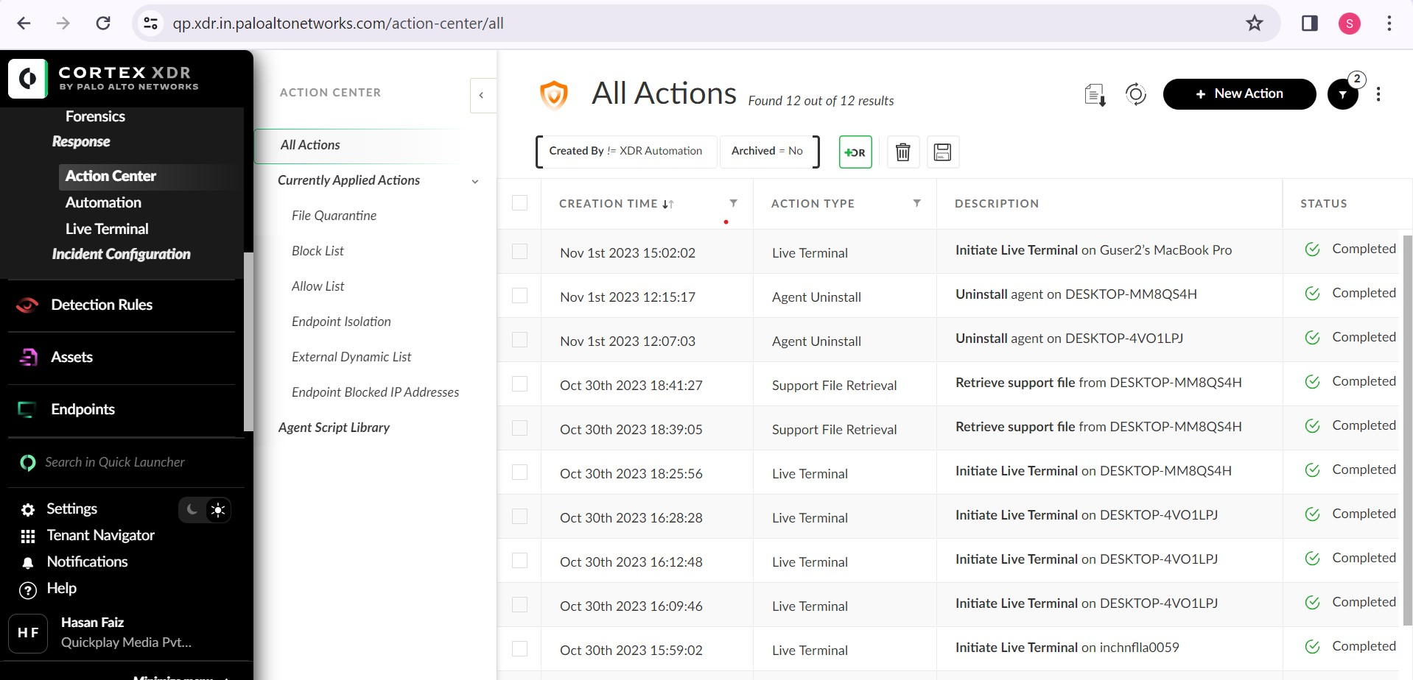

* **File Quarantine—**View details about quarantined files on your endpoints. You can also switch to an Aggregated by SHA256 view that collapses results per file and lists the affected endpoints in the Scope field.
* **Block List/Allow List—**View files that are permitted and blocked from running on your endpoints regardless of file verdict.
* **Scripts Library—**View Palo Alto Networks and administrator-uploaded scripts that you can run on your endpoints.
* **Endpoint Isolation—**View the endpoints in your organization that have been isolated from the network. For more information.
* **Endpoint Dynamic List—**View the list of IP addresses and domain names in your EDL. For more information.
* **Endpoint Blocked IP Addresses—**View remote IP addresses that the Cortex XDR agent has automatically blocked from communicating with endpoints in your network. For more information.

**Automation:**

Cortex XDR provides an easy way to automate the day to day activities of SOC analysts within XDR. Automation Rules enable you to define alert conditions that trigger the action that you specify within the rule. As alerts are created, Cortex XDR checks if the alert matches any of the alert conditions from the automated rules, and if there is a match, the corresponding action is then triggered. The automation rules only apply to new alerts which will either create a new incident or be combined with an existing one.

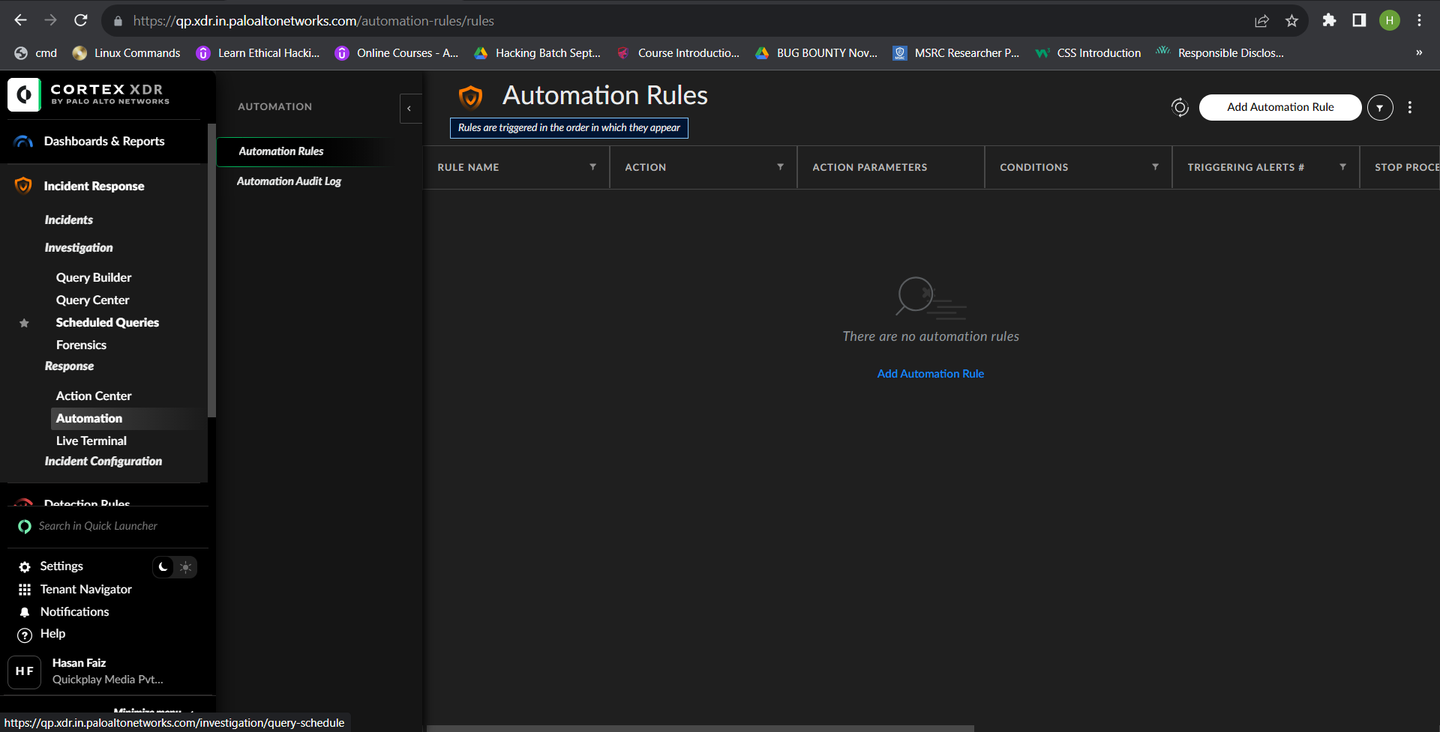

**Automation Rule:**

When creating the automation rule, the action is triggered when an alert matches the condition of the automation rule.

configure the following types of actions:

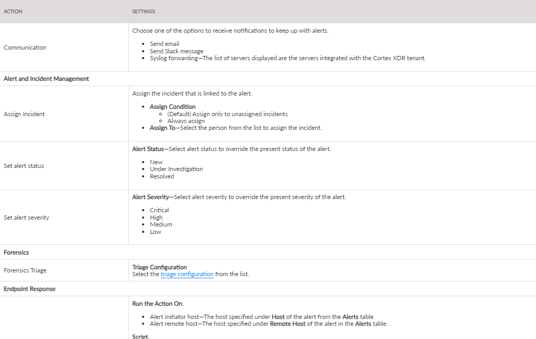

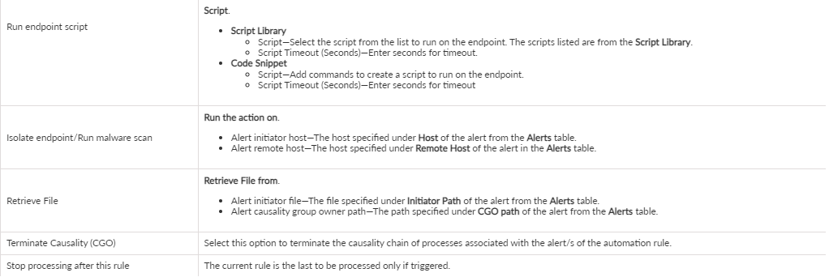

**Automation Audit Log:**

* The Automation Audit Log shows all the records of all the automation rule executions, included successful, failed and paused actions.
* The Automation Audit Log fields includes the following information.

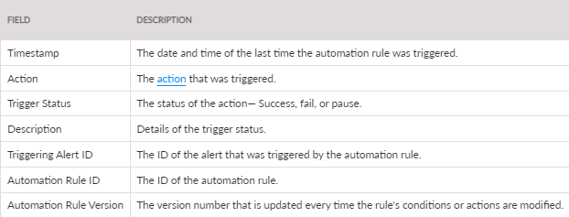

**Live Terminal:**

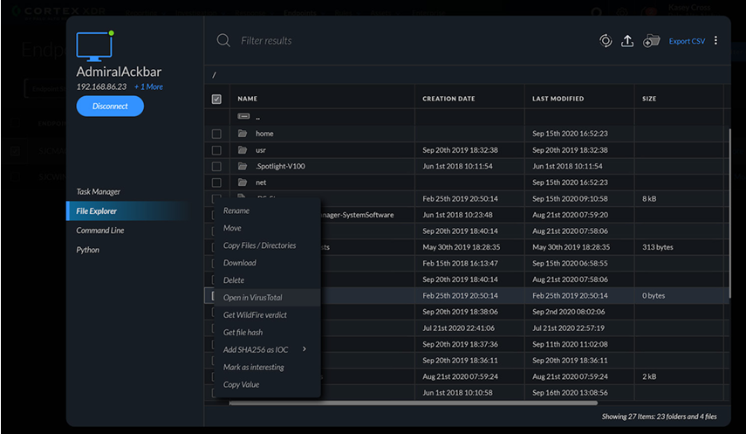

**Run Scripts on an Endpoint**

For enhanced endpoint remediation and endpoint management, you can run **Python** scripts on your endpoints directly from Cortex XDR .

* The following are prerequisites to executing scripts on your endpoints:
* Cortex XDR Pro Per Endpoint license
* Endpoints running the Agent v7.1 and later. Since the agent uses its built-in capabilities and many available Python modules to execute the scripts, no additional setup is required on the endpoint.
* Role in the hub with the following permissions to run and configure scripts:
* Run Standard scripts
* Run High-risk scripts
* Script configuration (required to upload a new script, run a snippet, and edit an existing script)
* Scripts (required to view the Scripts Library and the script execution results)

**3.Detection Rules:**

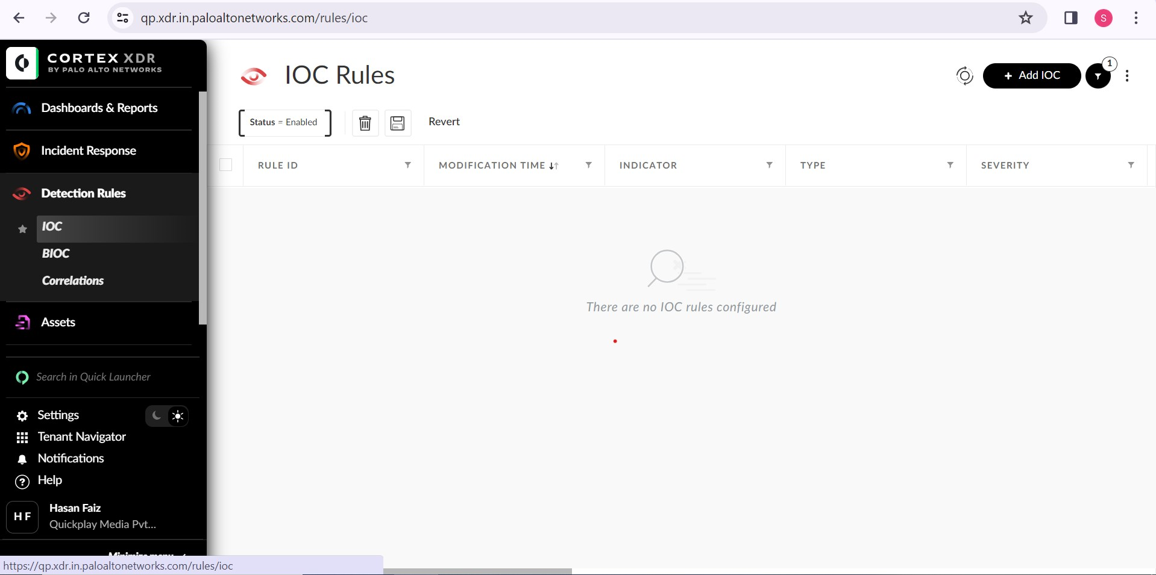

1. **IOC:**

IOCs provide the ability to alert known malicious objects on endpoints across the organization. You can load IOC lists from various threat-intelligence sources into the Cortex XDR app or define them individually.

Can define the following types of IOCs:

* Full path
* File name
* Domain
* Destination IP address
* MD5 hash
* SHA256 hash

1. **BIOC:** **Behavioural indicators of compromise (BIOC)**

Behavioural indicators of compromise (BIOCs) enable you to alert and respond to behaviours—tactics, techniques, and procedures. Instead of hashes and other traditional indicators of compromise, BIOC rules detect behaviour such as is related to processes, registry, files, and network activity.

1. **Correlations:**

Correlation Rules help you analyse correlations of multi-events from multiple sources by using the Cortex Query Language (XQL) based engine for creating scheduled rules called Correlation Rules. Alerts can then be triggered based on these Correlation Rules with a defined time frame and set schedule, including every X minute, once a day, once a week, or a custom time.

The following error messages are displayed in the applicable scenarios.

* Invalid query
* Query timeout
* Dependency correlation did not complete
* Unknown error
* Delayed rule—This rule is running past its scheduled time, which can cause delayed results.
* Dataset does not exist: <name of dataset>

**4.Assets:**

1. **Network Configuration:**

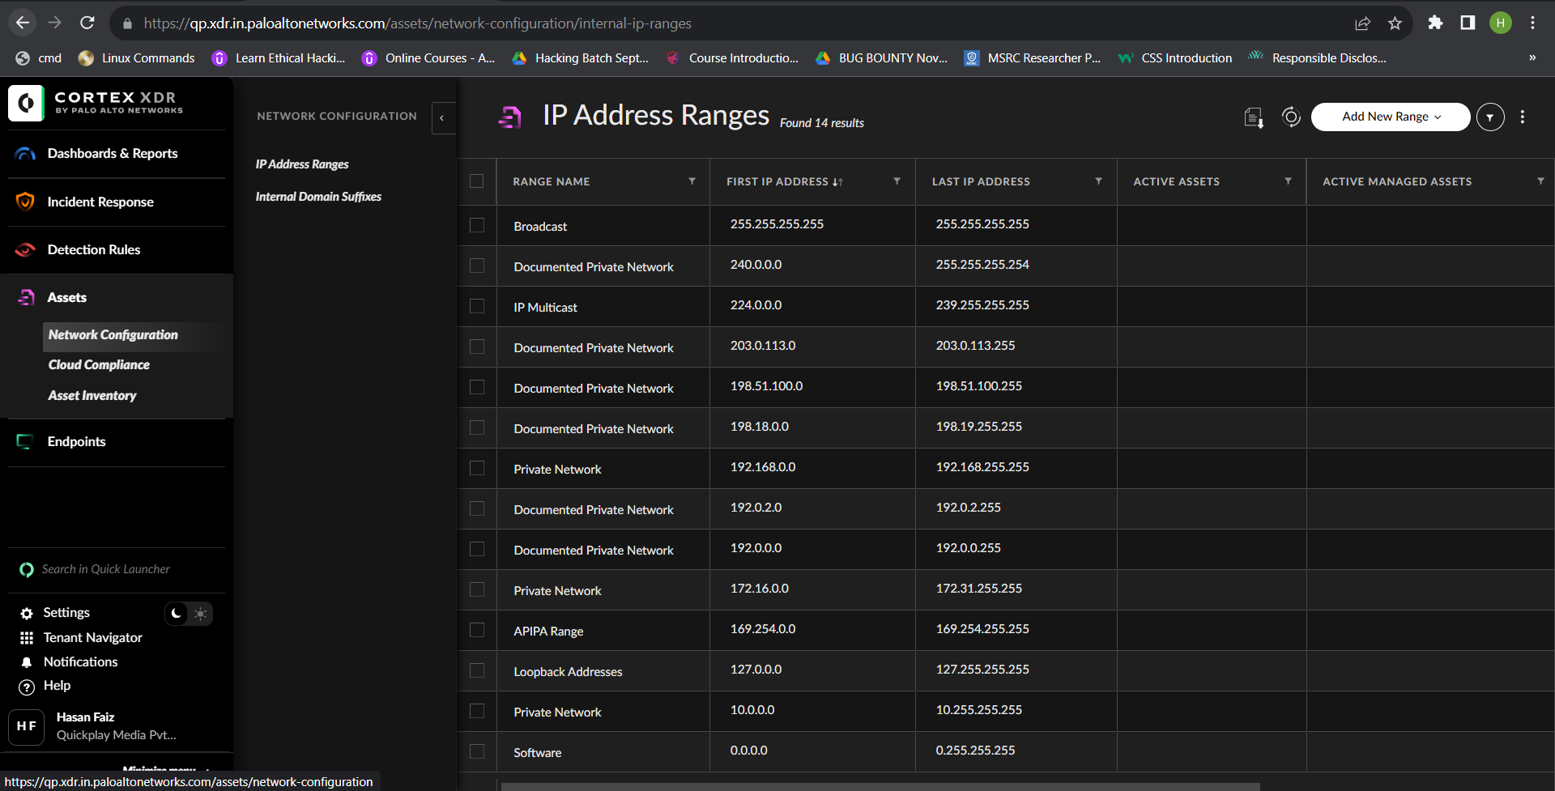

Network asset visibility is a crucial investigative tool in discovering rogue devices in your network and preventing malicious activity. Understanding how many managed and unmanaged assets are part of your network provides you with vital information to better assess your security exposure and track network communication.

Cortex XDR Network Configuration provides an accurate representation of your network assets by collecting and analyzing the following network resources.

* User-defined IP Address Ranges and Domain Names associated with your internal network
* EDR data collected by Firewall Logs
* Cortex XDR Agent Logs
* ARP Cache
* Broker VM Network Mapper
* Pathfinder Data Collector
* Distinguish between assets managed and unmanaged by a Cortex XDR agent.
* Identify assets that are part of your internal network.
* Track network data communications from within and outside your network.

1. **Cloud Compliance:**

Cloud Compliance performs the Center for Internet Security (CIS) benchmarking compliance checks on endpoint resources for Linux and Kubernetes agents. Cloud Compliance is mainly designed for cloud based Linux assets and Kubernetes hosts, but can also provide the same metric data for on-prem Linux appliances. As a result, Cloud Compliance provides you with an overview of violations in terms of Cloud Security posture on your Linux boxes in terms of Linux and container compliances, and also for Kubernetes, when applicable.

1. **Asset Inventory:**

Cortex XDR provides a central location from which you can view and investigate information relating to assets in your network. Using your defined internal network configurations, Broker VM Network Mapper, Cortex XDR agent, EDR data collected from firewall logs, and logs from third-party vendors, Cortex XDR is able to aggregate and display a list of all the assets located within your network. As soon as Cortex XDR begins receiving network assets, you can view the data in **Assets → Asset Inventory.**

**5.Endpoints:**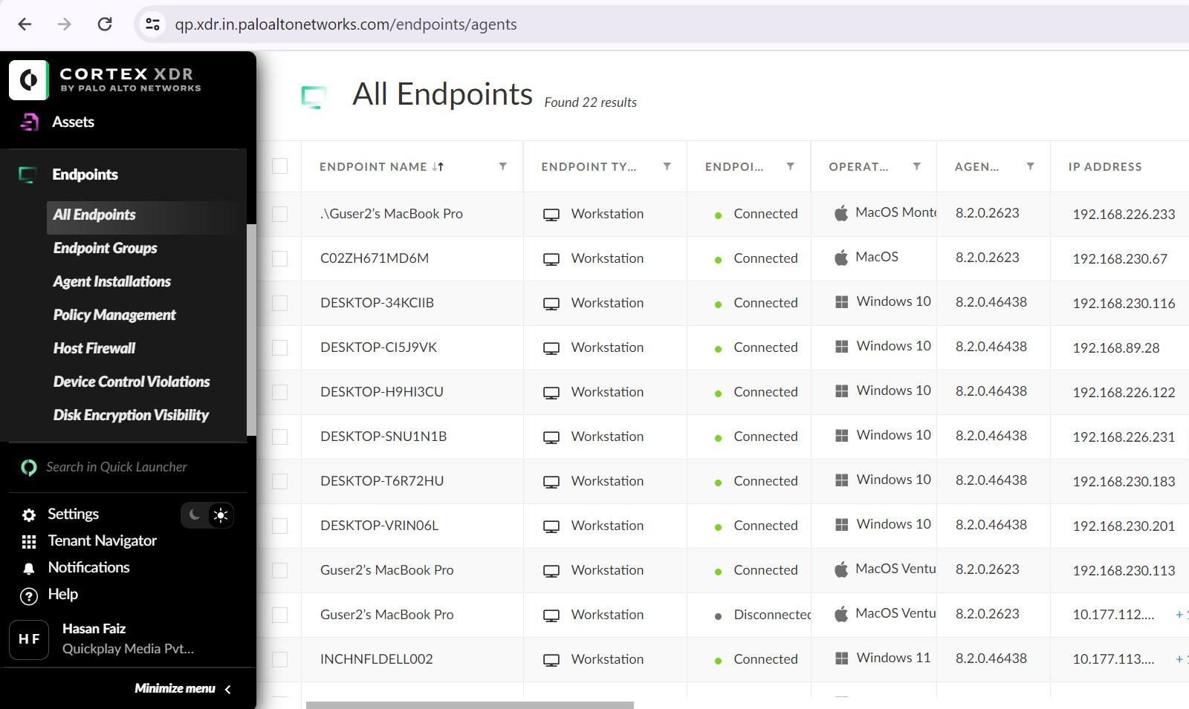

1. **All Endpoints:**
2. **Endpoint Groups:**

The Endpoint Groups page displays all endpoint groups along with the number of endpoints and policy rules linked to the endpoint group.

1. **Agent Installations:**

**Create Agent Installation:**

* Create a new installation package.
* Enter a unique Name and an optional Description to identify the installation package.
* Select the Package Type = Standalone Installers
* Select the Agent Version for the package = Recent Version
* Create the installation package.

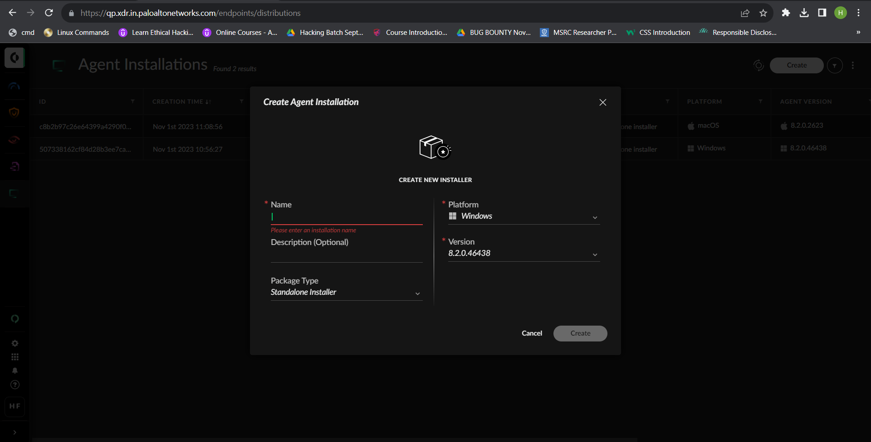

* Download your installation package.
* When the status of the package shows Completed, right-click the agent version, and click Download.

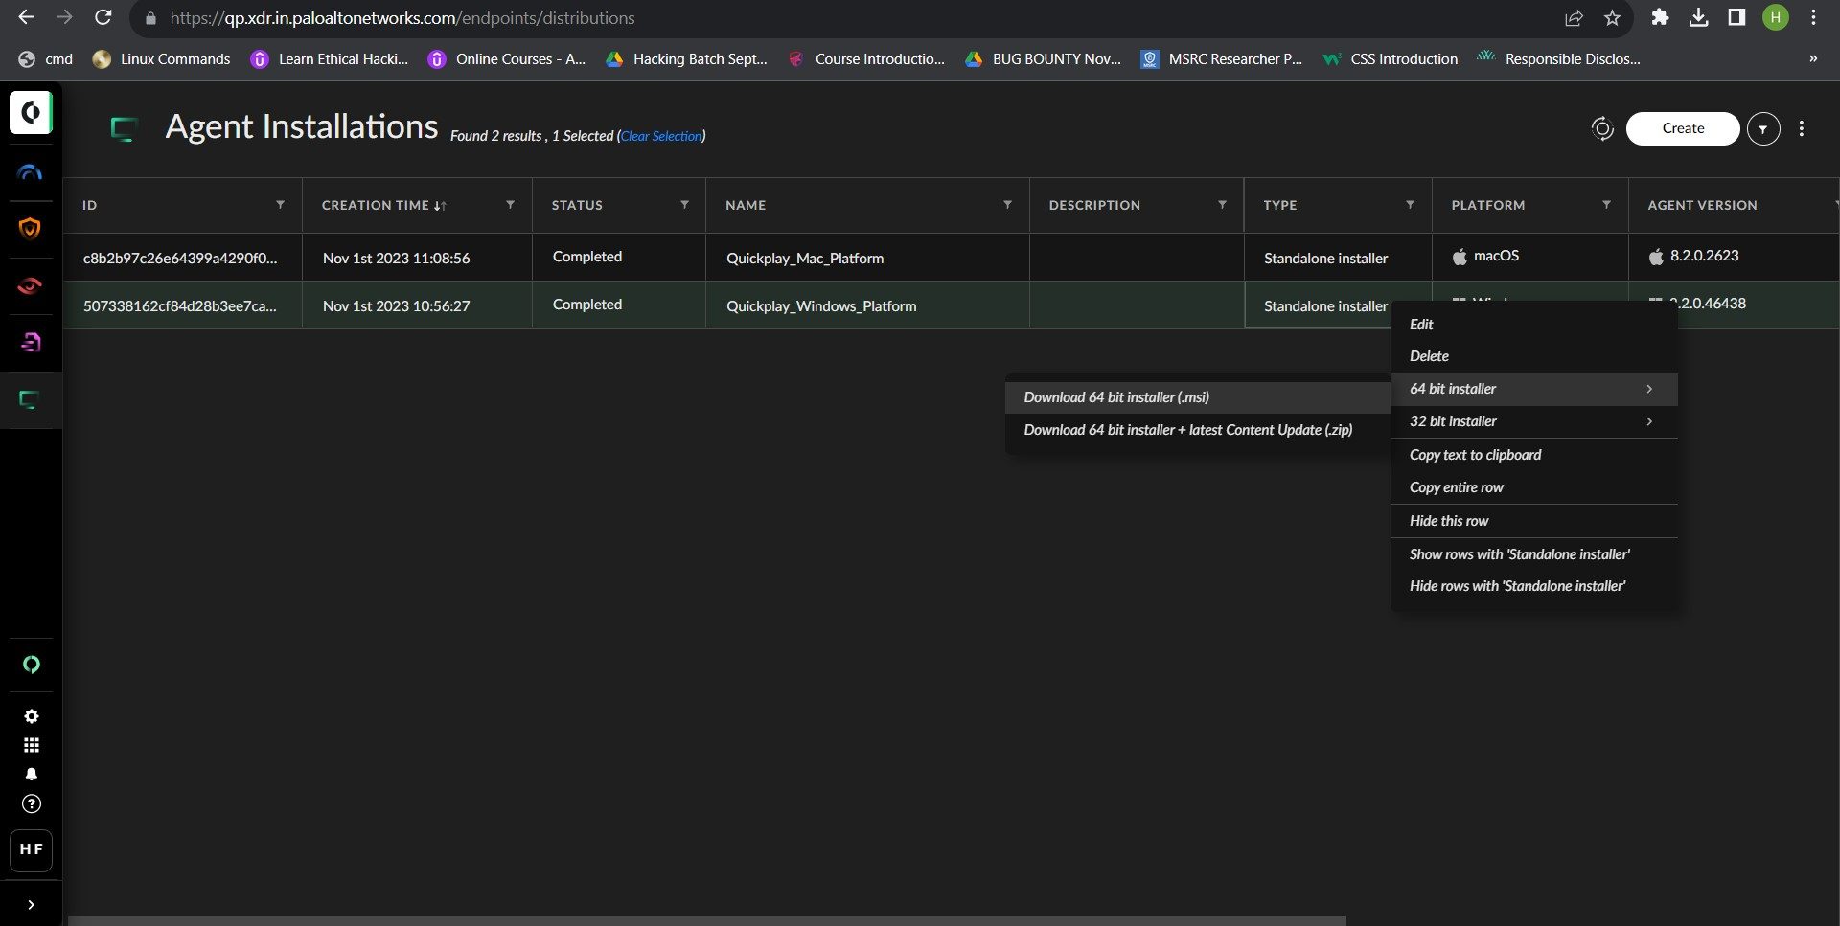

* Run the MSI file on the endpoint.

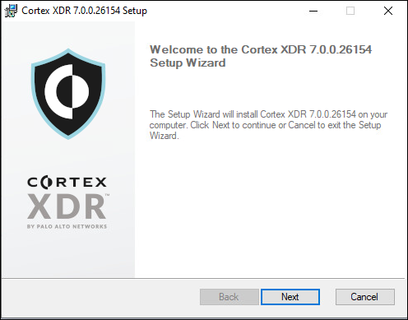

* Click Next.

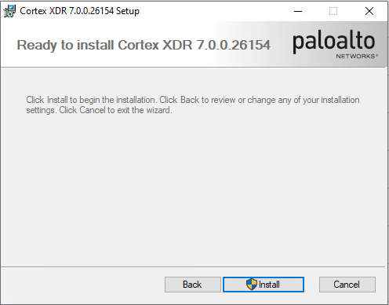

* Install the agent.

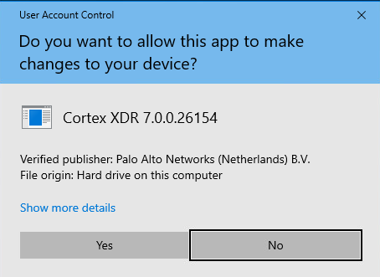

* Click Yes.
* After you complete the installation, verify the Cortex XDR agent can establish a connection in Agent Console.

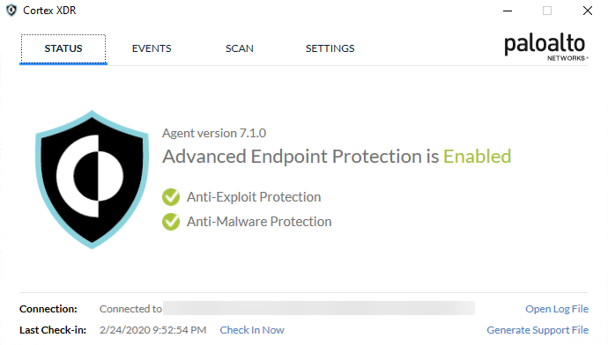

**4.Policy Management:**

**Endpoint Security Profile:**

**Security Profile Type:**

* + - Malware Profile
    - Exploit Profile
    - Agent Setting Profile
    - Restrictions Profile

**Windows Platform:**

1. **Malware Profile.**

* Portable Executable and DLL Examination
  + Analyze and prevent malicious executable and DLL files from running - Block
  + Quarantine Malicious Executable - Disabled
  + Action when file is unknown to WildFire - Run Local Analysis
  + Action when file is Benign with Low Confidence - Run Local Analysis
  + Upload unknown files to Wildfire - Enabled
  + Treat Grayware As Malware – Disabled
* Office Files with Macros Examination
  + Analyze and prevent malicious macros embedded in Microsoft Office (Word/Excel) files from running - Block
  + Action when file is unknown to WildFire - Run Local Analysis
  + Action when WildFire verdict is Benign Low Confidence - Run Local Analysis
  + Upload unknown files to Wildfire - Enabled
  + Examine Office Files From Network Drives – Enabled
* Global Behavioral Threat Protection Rules
  + Prevents sophisticated attacks that leverage built-in OS executables and common administration utilities by continuously monitoring endpoint activity for malicious causality chains – Block
  + Quarantine Malicious Files - Disabled
  + Action Mode For Vulnerable Drivers Protection - Block
  + Advanced API Monitoring – Disabled
* Credential Gathering Protection
  + Protection from processes trying to access/steal passwords and other sensitive credentials - Block
  + Quarantine Malicious Files – Disabled
* Anti Webshell Protection
  + Protection from processes dropping malicious webshells - Block
  + Quarantine Malicious Files – Disabled
* Financial Malware Threat Protection
  + Protection against techniques specific to financial and banking malware - Block
  + Quarantine Malicious Files – Disabled
* Cryptominers Protection
  + Protection against Cryptominers - Block
  + Quarantine Malicious Files – Disabled
* In-process shellcode protection
  + Prevents evasive attacks using shellcodes to load malicious code - Block
  + Quarantine Malicious Files - Disabled
  + Process Injection 32 Bit – Enabled
* Malicious Device Prevention
  + Protection against connecting potentially malicious devices to the endpoint – Block
* UAC Bypass Prevention
  + Protection against bypassing UAC mechanisms associated with process privileges elevation - Block
  + Quarantine Malicious Files – Disabled
* Anti-Tampering Protection
  + Protection against tampering attempts, including modification and/or termination of the Cortex - Block
  + Quarantine Malicious Files - Disabled
  + Malicious Safe Mode Rebooting Protection – Report
* IIS Protection
  + Protection against IIS related attacks – Block
* Respond to Malicious Causality Chains
  + Terminate Connection And Block Ip Address Of Remote Causality Group Owner – Enabled
* Ransomware Protection
  + Targets encryption based activity associated with ransomware to analyze and halt ransomware before any data loss occurs - Block
  + Quarantine Malicious Process - Disabled
  + Protection Mode – Normal
* Malicious Child Process Protection
  + Prevents script-based attacks used to deliver malware by blocking known targeted processes from launching child processes commonly used to bypass traditional security approaches – Block
* Endpoint Scanning
  + End-User Initiated Local Scan - Enabled
  + Periodic Scan – Disabled
* Password Theft Protection
  + Prevent attacks using the Mimikatz tool to extract passwords from memory – Enabled
* Network Packet Inspection Engine
  + Analyze network packet data to detect malicious behavior - Terminate Session

1. **Exploit Profile:**

* Browser Exploits Protection
  + Browsers can be subject to exploitation attempts from malicious web pages and exploit kits embedded in compromised websites. By enabling this capability, XDR agent automatically protects browsers from common exploitation attempts – Block
* Logical Exploits Protection
  + Attackers can use existing mechanisms in the operating system to execute malicious code. By enabling this capability, XDR agent automatically protects endpoints from attacks that try to leverage common operating system mechanisms for malicious purposes – Block
* Known Vulnerable Processes Protection
  + Common applications and process within the operating system can contain bugs and vulnerabilities that an attacker can exploit. By enabling this capability, XDR agent protects these processes from attacks which try to exploit known process vulnerabilities - Block
  + Java Deserialization Protection – Enabled
* Operating System Exploit Protection
  + Attackers can leverage the operating system itself to accomplish a malicious action. By enabling this capability, XDR agent protects operating system mechanisms such as privilege escalation and prevents them from being used for malicious purposes – Block
* Exploit Protection for Additional Processes
  + To extend protection to third-party processes that are not protected by the default policy from exploitation attempts, you can add additional processes to this capability – Disabled

1. **Agent Settings Profile:**

* General Information
  + Configure the disk space to allot for XDR agent logs.

Disk Quota (MB) – 5000

* User Interface
  + Configure user Interface options for the XDR agent console.
  + Tray Icon - Visible
  + XDR Agent Console Access - Enabled
  + XDR Agent User Notifications - Enabled
  + Live Terminal User Notifications - Notify only
  + Live Terminal Active Session Indication - Disabled
  + Persistent Isolation Notification - Disabled
  + Blocked Connectivity Notification - Disabled
* Agent Security
  + XDR Agent Tampering Protection - Enabled
  + Service Protection - Enabled
  + Process Protection - Enabled
  + Pipe Protection - Enabled
  + File Protection - Enabled
  + Registry Protection – Enabled
* Uninstall Password – Common Password

Set an uninstall password to remove XDR agent or to grant access to agent security components on the endpoint.

1. **Restrictions**

* Executable Files
  + Restrict file execution to pre-defined locations – Disabled
* Network Location Files
  + Restrict access to all network locations except for explicitly trusted ones – Disabled
* Removable Media Files
  + Restrict file execution launched from external drives attached to endpoints in your network – Disabled
* Optical Drive Files
  + Restrict file execution launched from optical disc drives connected to endpoints in your network – Disabled
* Custom Prevention Rules
  + User-defined prevention rules using BIOCs – Disabled

**Mac Platform:**

1. **Malware Profile:**

* Global Behavioral Threat Protection Rules
* Prevents sophisticated attacks that leverage built-in OS executables and common administration utilities by continuously monitoring endpoint activity for malicious causality chains – Block
* Quarantine Malicious Files – Disabled
* Credential Gathering Protection
  + Protection from processes trying to access/steal passwords and other sensitive credentials - Block
  + Quarantine Malicious Files – Disabled
* Anti Webshell Protection
  + Protection from processes dropping malicious webshells - Block
  + Quarantine Malicious Files – Disabled
* Financial Malware Threat Protection
  + Protection against techniques specific to financial and banking malware - Block
  + Quarantine Malicious Files – Disabled
* Cryptominers Protection
  + Protection against Cryptominers - Block
  + Quarantine Malicious Files – Disabled
* Anti Tampering Protection
  + Protection against tampering attempts, including modification and/or termination of the Cortex XDR agent - Block
  + Quarantine Malicious Files – Disabled
* Ransomware Protection
  + Protection against ransomware attacks - Block
  + Quarantine Malicious Files – Disabled
* Malicious Child Process Protection
  + Prevents script-based attacks used to deliver malware by blocking known targeted processes from launching child processes commonly used to bypass traditional security approaches - Block
  + Quarantine Malicious Files – Disabled
* Endpoint Scanning
  + Scan your endpoints for dormant malware that is not actively attempting to run – Disabled
* Mach-O Files Examination
  + Analyze and prevent malicious mach-o files from running - Block
  + Quarantine malicious Mach-O files - Disabled
  + Action on unknown Mach-O files to WildFire - Run Local Analysis - Enabled
  + Treat Grayware As Malware – Disabled
* Local File Threat Examination
  + Quarantine newly-created malicious non-Mach-O files, such as scripts, once they are written to disk - Enabled
  + Terminate Malicious Processes - Enabled
  + Quarantine Malicious Files – Disabled
* DMG File Examination
  + Analyze and prevent malicious DMG files from running - Block
  + Quarantine Malicious Executables - Disabled
  + Upload unknown files to Wildfire - Enabled

1. **Exploit Profile:**

* Browser Exploits Protection
  + Browsers can be subject to exploitation attempts from malicious web pages and exploit kits embedded in compromised websites. By enabling this capability, XDR agent automatically protects browsers from common exploitation attempts – Block
* Logical Exploits Protection
  + Attackers can use existing mechanisms in the operating system to execute malicious code. By enabling this capability, XDR agent automatically protects endpoints from attacks that try to leverage common operating system mechanisms for malicious purposes – Block
* Known Vulnerable Processes Protection
  + Common applications and process within the operating system can contain bugs and vulnerabilities that an attacker can exploit. By enabling this capability, XDR agent protects these processes from attacks which try to exploit known process vulnerabilities – Block
* Operating System Exploit Protection
  + Attackers can leverage the operating system itself to accomplish a malicious action. By enabling this capability, XDR agent protects operating system mechanisms such as privilege escalation and prevents them from being used for malicious purposes – Block
* Exploit Protection for Additional Processes
  + To extend protection to third-party processes that are not protected by the default policy from exploitation attempts, you can add additional processes to this capability – Disabled

1. **Agent Setting Profile:**

* User Interface
  + Configure user Interface options for the XDR agent console - Visible
  + XDR Agent Console Access - Enabled
  + XDR Agent User Notifications - Enabled
  + Live Terminal User Notifications - Notify only
  + Live Terminal Active Session Indication - Disabled
  + Persistent Isolation Notification - Disabled
  + Blocked Connectivity Notification – Disabled
* Agent Security
  + XDR Agent Tampering Protection – Enabled
* Uninstall Password - Common Password
  + Set an uninstall password to remove XDR agent or to grant access to agent security components on the endpoint.
* Alerts Data
  + Automatically Upload Alert Data Dump File - Disabled
  + Collect Prevention Data – Enabled

1. **Restrictions Profile:**

* Custom Prevention Rules
  + User-defined prevention rules using BIOCs - Disabled

1. **Host Firewall:**

The Cortex XDR host firewall enables you to control communications on your endpoints. To use the host firewall, you set rules that allow or block the traffic on the devices and apply them to your endpoints using host firewall policy rules. Additionally, you can configure different sets of rules based on the current location of your endpoints - within or outside your organization network. The Cortex XDR host firewall rules leverage the operating system firewall APIs and enforce these rules on your endpoints, but not your Windows or Mac firewall settings.

Create a Rules Group

1. **Device Control Violations:**

By default, all external USB devices are allowed to connect to your Cortex XDR endpoints. To protect endpoints from connecting USB-connected removable devices—such as disk drives, CD-ROM drives, floppy disk drives, and other portable devices—that can contain malicious files, Cortex XDR provides device control.

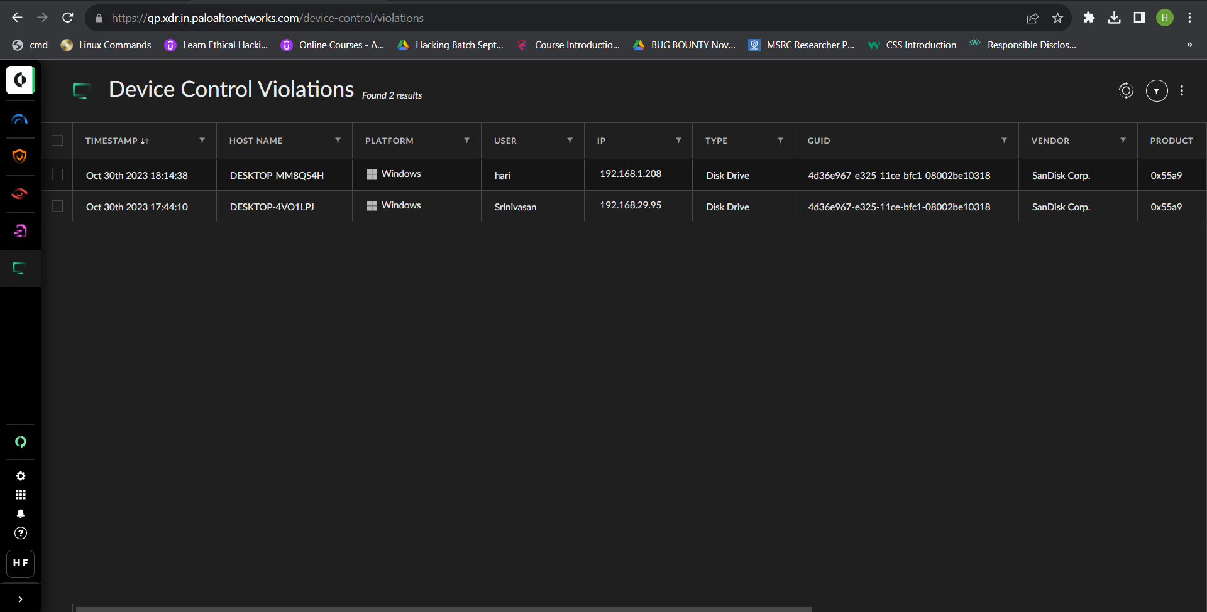

1. **Disk Encryption Visibility:**

Cortex XDR provides full visibility into encrypted Windows and Mac endpoints that were encrypted using BitLocker and FileVault, respectively. Additionally, you can apply Cortex XDR Disk Encryption rule on the endpoints by creating disk encryption rules and policies that leverage BitLocker and FileVault capabilities.

